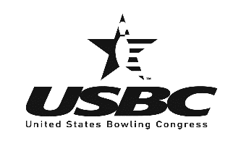
New Haven County USBC Inc. 27 New Street, West Haven, CT 06516
www.bowlnewhaven.com

The New Haven County USBC Association cordially invites you to attend our annual Association Banquet on Saturday, September 10, 2022 at 6:00 p.m. til 10:00 p.m. at Cielo Catering & Events at the West Haven Italian American Club facility located at 85 Chase Lane,
West Haven.

The deadline to RSVP is September 1st. Please send a check made out to NHCUSBC to the address below and fill out how many additional guests you have and their names so we can site you together accordingly. Please let us know if you will be attending or not ASAP for we need a firm number of attendees.

We hope you will join us in inducting Willie Hanna and Steve Lynn into the Hall of Fame as well as honoring our tournament winners, Bowlers of the Year and special recognition award winners.
…………………………………………………………………………………………………

Name: ______________________________ Phone Number:____________________________

Send to: Amity Bowl
Attn: Sheila Plavcan or Barbara Watts
30 Selden Street
Woodbridge, CT 06525

Number of Guests: _______ List names: 1)
2)
3)
4)

___(#) guests ($60/pp) ________
Total Due: ________

Amount Enclosed ________

